Graph Theory Assignment-2

Roll number: CSB23017
Name: Raktim Ranjan Handique
Session: Spring Year:2025

Objective:
To use Dijkstra’s Algorithm to find shortest paths to all other location considering your hostel as the source

Details of work
Locations
: Important Locations
: 1. Hostel (Source)
2. KBR Auditorium
3. Central Library
4. HSS building
5. CSB Hall
6. Academic Building 1
7. VC Residence
8. Guest House
9. Dept. of MBA
10. Staff Quarters
11. SOE Dhaba
12. CSE Dept.
13. Essential Store
Distances
: 1 - 2 : 500m
1 - 3 : 500m
1 - 13 : 300m
13 – 7 : 350m
7 - 10 : 500m
3 - 2 : 290m
3 - 4 : 550m
4 - 5 : 220m
4 - 10 : 290m
7 - 8 : 130m
8 - 9 : 210m
2 - 6 : 400m
2 - 13 : 400m
5 - 10 : 200m
5 - 6 : 10m
9 - 12 : 350m
9 - 11 : 350m
11 - 12 : 220m
10 - 11 : 500m

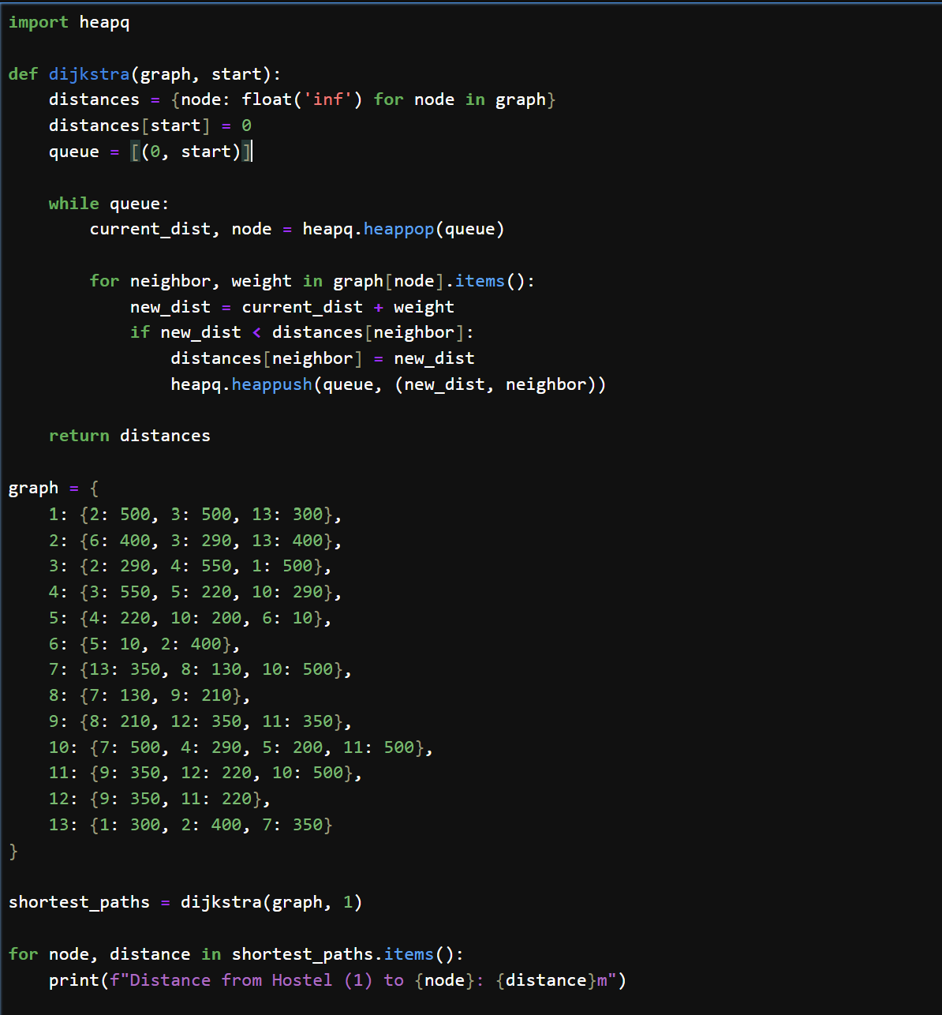

Output
: 